Assessment Framework International Cooperation and Knowledge Security (TISK) UM

General principle
Internationalisation is crucial for the quality of education and research. It is for this reason that UM has internationalisation high on the agenda. International cooperation in education and research is inextricably linked to that. The starting point, therefore, is that UM welcomes cooperation with foreign parties, knowing that international cooperation contributes in a meaningful way to our strategic goals, our education, research, the development of students and employees.
Upon entering into a new international cooperation or upon evaluating an existing international cooperation, there are two viewpoints that need to be considered:
- A policy/strategic perspective: What goal do we aim for with the cooperation?
- A knowledge security perspective: What risks are involved in a specific cooperation?
The policy/strategic perspective determines to what extent a specific cooperation contributes towards the wider goals we have set for ourselves. The knowledge security perspective determines whether the risks related to a specific cooperation are acceptable or not.
In the context of geopolitical, technological and societal developments international cooperation for knowledge institutions is becoming more and more complex. Knowledge and innovation is increasingly seen as a strategic means of power of state-allied actors. We must be prepared for the risks we run in this respect. These risks are related to:
- undesired transfer of sensitive knowledge and technology with negative consequences for national security and innovative power of the Netherlands;
- covert influencing and interference activities, possibly resulting in (self-)censorship and as such in infringement of academic freedom;
- cooperation with persons and/or institutions from countries not respecting fundamental rights.
In the framework of knowledge security, UM needs to comply with the Guideline Knowledge Security of the Ministry of Education, Culture and Science. In addition, UM has committed itself to academic standards and ethical principles. Without our knowledge, for example, our expertise and technology may not be used for military purposes (“dual use”) or put to use by other parties for commercial purposes. We aim for cooperation, but not until these risks have been explicitly assessed.

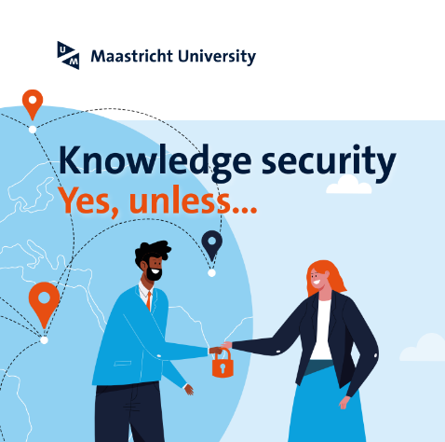
The Assessment Framework International Cooperation and Knowledge Security (TISK) has been developed as a guideline for UM employees, management and board for the purpose of assessing and evaluating international cooperations. The TISK has been divided into two separate parts. In the first part, the goal of the cooperation is assessed by means of a number of questions from a policy/strategic viewpoint. In the second part, the knowledge security risks are assessed.
The TISK is a tool. Developed to pose a number of key questions in a systematic way upon entering into an international cooperation. As such, it will provide a starting point for employees as well as management and board members when assessing the goal(s) as well as the risks of a suggested cooperation, so that design and implementation can be set up accordingly. The assessment framework is aimed at those initiating a cooperation as well as those who have to evaluate it.
This assessment framework can be applied to all situations of collaborating with foreign partners:
- entering into cooperation or partnerships with foreign universities;
- entering into cooperation or partnerships with all other foreign or international organisations;
- entering into any form of cooperation with legal implications/obligations (contracts);
- but also entering into forms of cooperation that are intentional without legal implications/obligations (like MoUs e.g.)
Examples of agreements can be in the field of:
- Student exchanges;
- Educational partnerships (double degree arrangements, the exchange of or cooperation in teaching modules, staff exchanges);
- The execution of educational cooperation projects with foreign partners (usually with funding contracted externally, like Erasmus+);
- Research cooperation in any form conceivable;
- Agreements aimed at the exchange of PhD students, joint supervision of PhD students, double doctoral degree arrangements;
- The execution of research projects and programmes together with foreign partners (usually with funding contracted externally, like in a EU context)
- The execution of projects with international (university or otherwise) partners (usually with funding contracted externally, like Dutch development aid, EU, UN organisations, World Bank et cetera)
- The employment of foreign (non-EEA) personnel.
Completing the Assessment Framework is supported by a template which will be published on the Intranet site.

Part I: Assessment Framework International Cooperation
The assessment framework below consists of a checklist with questions in the case of an intended cooperation with (a) foreign partner(s). With these questions, the motives for the potential cooperation are weighed up against the strategic goals of the organisation. At the same time, a number of risks are identified and listed. This part is not compulsory upon entering into an international cooperation.

What is the goal of the cooperation?
One should formulate clear goals for the cooperation and check whether the intended goals can actually be achieved, and whether the cooperation with this partner contributes to that end.

What is the intended type of cooperation?
Is it a university-wide cooperation, a faculty cooperation or a cooperation at the level of departments, institutions or similar units? Is it about one particular activity (like research cooperation, student exchange, staff exchange) or multiple activities? Which partners are (in)directly involved in the cooperation?

What are the intended results (‘deliverables’) of the cooperation?
What concrete results will be pursued in the cooperation? And within which time frame will these results be achieved?

What is the motivation for cooperating with this (these) partner(s)?
Why has the choice fallen on this (these) partner(s) in specific? Why is it that the intended results can be achieved by cooperating with this (these) specific partner(s)?

Are there already partnerships with this (these) institution(s) within UM, or have there been in the past? If so, what are/were the experiences?

What is the added value of the cooperation for UM?
How does UM benefit from cooperating with this partner? What is the meaning of this cooperation to UM? How does the cooperation tie in with the strategic goals of UM?

What is the added value of the cooperation for the intended partner(s)?
Which interest do(es) the partner(s) have in this cooperation? It is of fundamental importance to obtain an adequate picture of that. The interest of the partner(s) in this cooperation is not necessarily the same as the interest of UM.

Are there any formal aspects involved in the cooperation that require a form of written agreement?
If the implications of the intended cooperation are such that arrangements need to be set out in writing, an appropriate form needs to be determined to do so. Legal Affairs (LA) can provide standard templates for intentional, not legally binding (e.g. MoUs) and for legally binding (contracts) agreements. Please note that according to the UM mandate regulation the authority to sign MoUs and agreements lies with the Executive Board (in case of UM-wide cooperation) or with the dean of the faculty (in case of cooperation with – part of – the faculty).

Are there any practical aspects involved in the intended cooperation that need to be taken into consideration?

Like for example (cost of) accessibility, possible visa requirement (both ways), insurance, safety et cetera. Will all those involved be adequately informed?

Are there any financial implications/obligations related to the cooperation?
Please consider any costs of the (various parts of the) cooperation, which party covers which costs and what the implications are for rights, obligations and responsibilities of the partners.

Are there any risks involved in the cooperation? In which way(s) can they be mitigated?
- Are there any risks involved in this cooperation in the context of Knowledge Security?

If the answer is ‘yes’, please complete Part II of the Framework Knowledge Security UM.

- Are there any other risks involved in the cooperation? For example:
  - Can all partners freely make use of the academic content (research results, teaching materials) of the cooperation?
  - Is it necessary to make agreements about intellectual property right and sharing data?
  - Does data management of the intended partner(s) comply with current standards?
  - Are employees and/or students involved in the cooperation in danger of running political and/or security risks?
  - Can academic freedom possibly be at stake at any time?
  - Are there are financial risks involved? Is there sufficient security that all partners can meet the financial commitments they have assumed in the cooperation?

Is cooperation with this partner possibly not permitted/undesirable?
If there is any doubt whatsoever regarding this aspect, all steps in the Framework Knowledge Security UM (Part II) need to be completed. In such cases there is a legal obligation to assess the intended cooperation against the described knowledge security criteria.

Part II: Assessment Framework Knowledge Security
In order to arrive at a balanced and consistent opinion about a (potential) cooperation, the Assessment Framework Knowledge Security is part of the TISK. This part of the Assessment Framework is compulsory in case of any doubt about Knowledge Security risks.
The assessment framework has been developed as a national tool and consists of three steps. In the first step we must find out if there is any regulation with regard to the cooperation partner(s) and the research area that we need to comply with. In the second step we test the cooperation against available national and international lists and reports in order to manage the risk in the field of knowledge security. These lists serve as tools to help us evaluate the risks. In this, the Executive Board has already made some decisions on main outlines. In the last step upon entering into a cooperation, we use partnering tools that help us shape the research and minimise risks.

Step 1
Legal framework
- SANCTIONS LIST:
Are the prospective employee, and/or relevant contacts of the prospective candidate, and/or the institute/organisation where the candidate has worked and/or studied, as stated on the CV, included on the EU Sanctions List?
Are the intended partner organisation, their concern relations, and/or persons from the board included on the EU Sanctions List?
Click here for the EU Sanctions List Proceed to click on ‘consolidated list of financial sanctions’ and download the list.
Why do we ask this?
Collaborating with institutes and/or persons listed on the EU Sanctions List is prohibited by law. Establishing a collaboration with a sanctioned entity leads to violation of the sanctions law, which constitutes an economic offence.
- HEIGHTENED SUPERVISION:
Is the field of research or education to which the candidate or project will contribute to subject to heightened governmental supervision?
Areas of heightened supervision concern technical research and education that contributes to the development of highly sensitive knowledge. UM currently does not have any fields of research that are subject to heightened supervision, but this can change in the future. For more information, see the governmental webpage Kennisembargo (in Dutch).
Why do we ask this?
Certain research and education in the Netherlands brings forth knowledge with which nuclear weapons, weapons of mass destruction or relevant means of transmission can be produced or developed. Therefore, anyone who can obtain access to such sensitive knowledge (e.g. students, researchers and technical staff) must apply for a licence before starting with the research project or education. Without licence, it is not possible to start a course or research project, or access to these (specialist) areas will be denied.
- DUAL USE / EXPORT CONTROLS:
Is the subject of research, in which the prospective candidate or to which the project will contribute, subject to Dual Use or Export controls?
Do the research or education activities use or produce knowledge about technological sensitive items (strategic goods), or are such technologically sensitive items produced within the intended collaboration? If so, one may likely need an export licence.
Step 1
Legal framework
The Dutch export control policies follow international (European or other international) arrangements and regulations. All higher
education and research institutes need to comply with the following four (4) elements of the multilateral export regulations:

- The Wassenaar Arrangement, concerning export controls for conventional weapons and sensitive items and technologies for
dual use purpose;
- The Australia Group (AG) for biological and chemical weapons;
- The Nuclear Suppliers Group (NSG), concerning export controls for nuclear materials, equipment and technologies for dual use
purpose;
- The Missile Technology Control Regime (MTCR), which follows the EU-Iran 212/2012 sanctions. These sanctions have lead to
mandatory screening of staff and students in certain fields of research.

Areas of research that previously have been subjected to export controls for dual use items can be found in Annex 1 of the EU recommendations concerning dual use.
More information about export controls can be found on the website of the Dutch RVO.
Information about how to apply for an export licence can be found here (in Dutch).
Why do we ask this?
Strategic goods (i.e. military, dual use or sanctioned goods) risk to be used for undesired (wrongful) purposes. Mandatory licencing for the export of strategic goods and related services has been introduced as a means to avoid such undesired application. If the risk of undesired (wrongful) application is deemed too high, a licence may not be issued. If controlled goods are exported without licence, this violates EU regulations. Economic crimes are punished under the Economic Offences Act (2021).
- MILITARY RELATIONS:
Is the institute/organisation at which the prospective employee has studied and/or worked, or with which the collaboration is intended to be realised, affiliated with a military organisation outside of the EU?
If the institute/organisation is based in China, one can do a first military relations check on the website of the Australian Strategic Policy Institute (ASPI Unitracker). This website contains a list of 52 Chinese universities with military ties to the Chinese army and qualifies universities based on their risk level, including the National University of Defence Technology (NUDT). Also listed are the so-called ‘7 Sons Universities’: the national and public Chinese research universities that operate in the interests of the Chinese Ministry of Industry and Information Technology. It is generally acknowledged that these universities have close ties and intensively collaborate with the Chinese army.
The ‘7 Sons Universities’ are:
- Beihang University in Haidan, Bejing
- Beijing Institute of Technology in Haidan, Beijing
- Harbin Engineering University in Harbin, Heilongjiang
- Harbin Institute of Technology in Harbin, Heilongjiang
- Nanjing University of Aeronautics and Astronautics in Nanjing, Jiangsu
- Nanjing University of Science and Technology in Nanjing, Jiangsu
- Northwestern Polytechnical University in Xi’an, Shaanxi
Why do we ask this?
Collaborating with military organisations outside of the EU poses considerable risks, such as the risk of undesired (wrongful) application of goods and technologies, and are therefore considered undesired. Moreover, all export to military end-users in countries that are subject to a weapon embargo (click on the menu Measures Cross check “arms embargo”) are in need of an export licence.
Concerning China: UM generally does not allow collaborations with the ‘7 Sons Universities’ mentioned above. If it is desired to establish a collaboration with a military organisation, the Knowledge Security office will have to present the case to the Executive Board (CvB).
- FINANCES/FUNDING:
Does the prospective employee/candidate or project receive funding from a non-Dutch funding agency? If so, from which funding agency?
If not, what other source of funding is used to finance the position/project? Are there any additional conditions or financial interests attached to these funds?
If the prospective employee/candidate receives funding from an organisation under authoritarian control, or if the intended partner organisation is located in an area under authoritarian control, one can check the Democracy Index rating of that particular area/country.
The ASPI list has 4 qualifications. Each qualification comes with a general preliminary advice:
Very High risk Cooperation is very undesirable
High risk Avoid dual use research, even if there is no licence requirement
Medium Risk Stay away from defence-related research departments
Low Risk Avoid sensitive research areas

Step 2
Risk management Knowledge security
In case the intended collaboration involves entities from countries that score between 0-4 (colour code red-orange), it is necessary to motivate the surplus value as opposed to the risks (e.g. covert influence) towards one’s dean.
With regard to China, UM’s general policy on China Scholarship Council (CSC) scholarships is as follows:
- No CSC scholarship students in sensitive research areas (see section F);
- No CSC scholarship students from NUDT, the 52 military universities or the 7 Sons Universities (see section D);
- Accepting: incoming CSC scholarship students, selected by UM, on UM-based subjects, with PhD supervision in Maastricht. Co-supervision from China is possible, provided that the supervisor and second supervisor from UM are involved in the project;
- Incoming CSC scholarship students for 1 or 2 years with supervision from China will need to be evaluated on a case-by-case basis. An important precondition for such collaborations is reciprocity.
Why do we ask this?
Allowing researchers (scholarship students) to work on projects in which sensitive technology is used or developed poses risks. This applies mainly to researchers originating from areas under authoritarian control. These areas/countries often also receive a low score on the Academic Freedom Index. Consequently, there is a risk of covert influence (e.g. by state actors), which can compromise academic freedom and scientific integrity.
The source of funding has a direct impact on the security, control and ethical application of knowledge. It determines who has access to, control over, or can use certain knowledge and technology. This has implications for the protection of strategic, economic and possibly also national interests. Therefore, it is essential that funders/funding sources are carefully assessed in terms of reliability, transparency and strategic interests, in order to safeguard knowledge security and to minimise risks such as undesired or covert influence.
- SENSITIVE TECHNOLOGIES:
Does the subject of research in which the prospective employee/external PhD candidate/visiting researcher is active, or to which the project will contribute to, fall under the category of ‘sensitive technologies’ and does the collaboration involve a partner from a high-risk area/country?
The combination of sensitive technology and collaboration with an entity from a high-risk area is, in principle, not permitted at UM.
Sensitive technologies, also referred to as ‘high risk research areas’, include technologies that the Dutch government considers to have specific military, economic and/or geopolitical strategic values.
The following research areas may involve technologies that can be considered sensitive:
Step 2
Risk management Knowledge security
Dual Use Technologies  - High performance computing  - Quantum computing  - Artificial Intelligence (AI)  - Advanced data analytics  - Simulation technology  - Cybertechnology  - Advanced materials  - Biotechnology/Life sciences  - Nanotechnology  - Optica/photonics (ET)  - Robotics & autonomous systems  - Sensing technologies  - Logistics (infrastructure) | Key Technologies  • Advanced materials  • Chemical technology  • Digital technology (incl. AI)  • Life science technology  • Regenerative medicine | Emerging Technologies  • Artificial Intelligence (AI)  • Biotechnology  • Blockchain  • Smart materials  • Sensing technology  • (Molecular) imaging
Why do we ask this?
In order to effectively minimise risks, it is necessary to identify sensitive research domains. Sensitive technologies oftentimes have specific strategic, economic or military purposes and values. Knowledge Security policies aim to protect sensitive knowledge from undesired access, espionage, theft or uncontrolled distribution, in order to safeguard national security, our economic competitiveness, and societal stability.
- ETHICAL AND MORAL DILEMMAS:
Are there any (other) ethical or moral dilemmas associated with hiring the prospective candidate or the intended collaboration with the prospective person/organisation?
We must be particularly attentive when collaborating with partners from areas in which fundamental rights are not (always) respected. Examples of ethical or moral dilemmas include violations of human rights or academic values, when the safety of researchers cannot be guaranteed, when there is a risk of oppression or coercion, when knowledge may be misused (wrongful purpose), or when there is a risk of unintended transfer of knowledge (diversion). Also covert influence and interference activities that can lead to (self-)censorship, and thus may undermine academic freedom, can be considered.
Step 2
Risk management Knowledge security
Why do we ask this?
The core values of ‘academic freedom’ and ‘scientific integrity’ are paramount to UM. When these core values risk to be compromised as a result of an international collaboration, caution is needed. Risk factors include the possibility of pressure and coercion through (state) interference or covert influence.
Moreover, it is highly undesirable to contribute to human rights violations anywhere in the world. If there are suspicions that a project or partner may contribute to the violation of human rights, please consult the Human Rights Due Diligence Framework (HRDD).
UM also does not want to collaborate with partners that hinder the transition towards a fossil-free, climate neutral society. For collaborations with entities that are active within the fossil-fuel industry, please consult the Fossil-free Society assessment framework.

- SENSITIVE (PERSONAL) DATA:
Does the intended collaboration or project make use of, or produce personal data or technologically sensitive data (see also section F)?
If so: has there already been drafted a Data Management Plan (DMP)?
According to UM’s Open Science policy (2022-2026), UM strives to make Open Sciences practices the norm, using the credo “as open as possible, as closed as necessary”. This ambition may induce some knowledge security risks. An important aspect of knowledge security concerns the risk of leakage of data, information or knowledge, in any form possible. Most research involves the usage of, or creation of data. In most occasions, it is therefore necessary or desired to draft a Data Management Plan (DMP), which describes how data can be collected, stored and shared safely, following GDPR guidelines. For more information, consult this link.
Why do we ask this?
When using or creating (research) data, the data may be subject to privacy (GDPR) laws. In some cases, there may be patentable knowledge involved.
When collaborating with a foreign organisation/entity or when hiring staff from high-risk areas, there is a risk of covert influence. Besides that this can lead to data security issues, it can negatively impact the quality of the data. Therefore, a robust approach, in which technological safety measures go hand in hand with legal regulation and ethical awareness, is of crucial importance for safeguarding knowledge security. In this way, technological progress can be achieved, while simultaneously guaranteeing the security of sensitive knowledge.
Step 2
Risk management Knowledge security

Step 3
Organisation and setting out cooperation
- If the previous steps have not resulted in any obstacles regarding the cooperation, the arrangements can be set out or the hiring process started.
To this end, the usual processes can be followed.
Partnering tools have been developed to assist you in drawing up agreements or contracts. The tools provide a concrete guide for implementing many of the recommendations from the National Guideline Knowledge Security.
The partnering tools can be found on the intranet site Knowledge Security.

The tools include guidelines for all stages of a cooperation: from researching and selecting a partner (phase 1), the negotiations (phase 2), the actual cooperation (phase 3) up to the evaluation (phase 4). For each phase so-called quick guides have been developed that equip and support researchers to cooperate with international partners in a secure way. The complete set of tools cover the following elements:

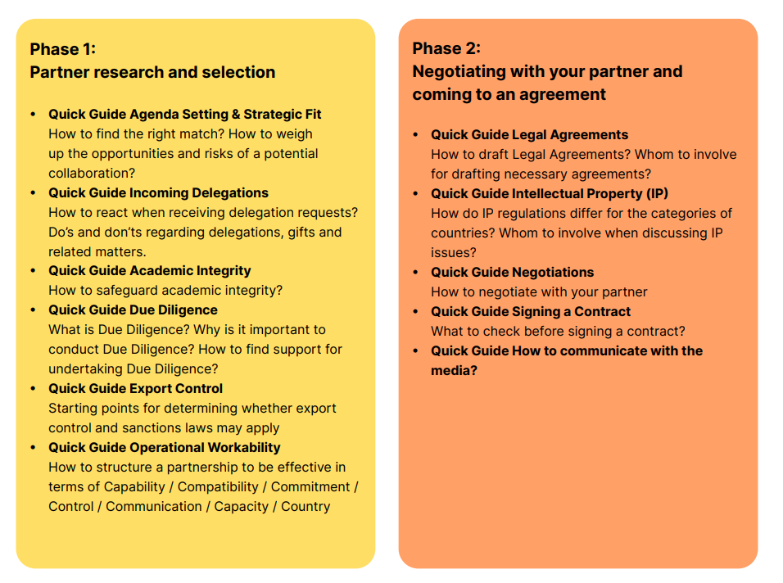

Step 3
Organisation and setting out cooperation
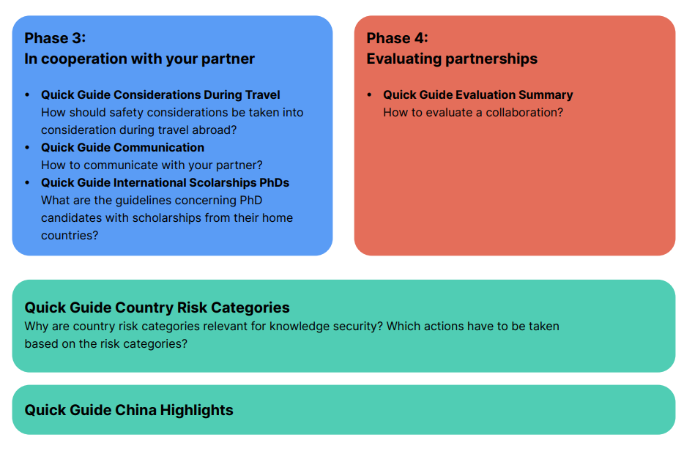

NOTE: UM complies with agreements from the past unless this is against the law or unless moral grounds do not or no longer justify compliance.

