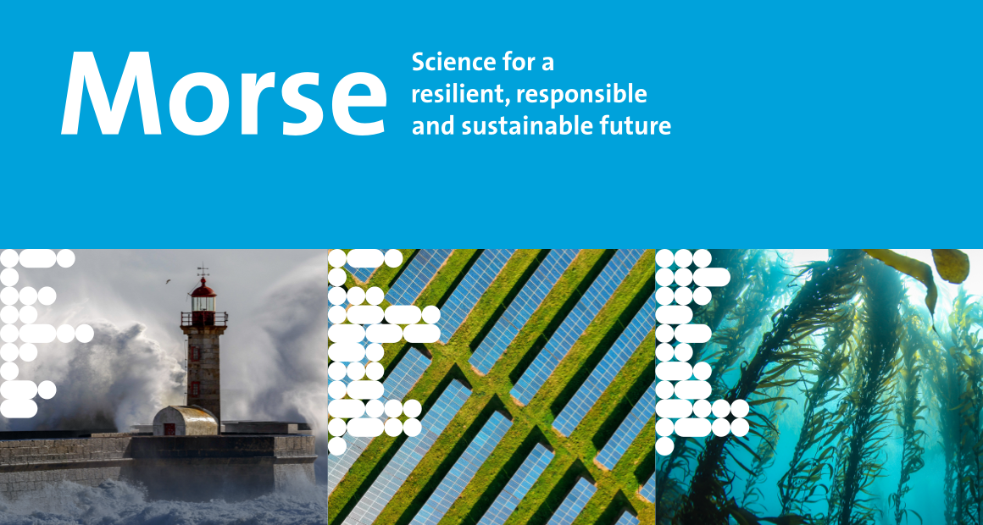
Call for Papers
Maastricht Observatory for Responsible, Resilient and Sustainable Societies, Economies and Enterprises
3rd Annual Conference 2023
Track: Finance and Resilience
Maastricht, the Netherlands, 23-25 October 2023

Track Chairs:
Jaap Bos, Vinzenz Peters

Description of the track

The financial sector plays a crucial role in building a resilient and sustainable economy. With the increasing awareness of the risks and opportunities of climate change, environmental degradation, and social inequality, there is a growing demand for responsible and sustainable finance. Financial institutions are facing new challenges, such as measuring and managing climate risks, promoting sustainable investments, and supporting the transition to a low-carbon economy. At the same time, the financial sector is also exposed to these risks and needs to ensure its own resilience in order to contribute to a resilient real economy. This track aims to explore the role of finance in building resilience and to discuss the challenges and opportunities for responsible and sustainable finance in the face of environmental, social, and economic pressures.

Key topics and research questions of the track

- Sustainable finance: What are the challenges and opportunities for sustainable finance, and how can financial institutions promote sustainable investments and support the transition to a low-carbon economy?
- Climate risk management: How can financial institutions measure and manage climate risks, and what are the implications for risk management practices and financial stability?
- Resilient financial systems: How can financial systems become more resilient to external shocks, such as climate change, pandemics, and financial crises? What are the implications for financial regulation and supervision? What role does the financial sector play in the resilience of the real economy?
- Socially responsible investing: How can investors integrate environmental, social, and governance (ESG) factors in their investment decisions, and what are the effects on financial performance and risk? What is the role of green bonds and other sustainable financial instruments in promoting sustainable investments, and how can they be designed to maximize their impact?
- Financial innovation for sustainability: How can financial innovation contribute to sustainable development, and what are the challenges and opportunities for new financial technologies, such as blockchain, fintech, and digital currencies?

References:
Battiston, S., Mandel, A., Monasterolo, I., Schütze, F., and Visentin, G. (2017). A climate stress-test of the financial system. Nature Climate Change, 7(4):283–288. https://doi.org/10.1038/nclimate3255

Bolton, P., Kacperczyk, M., Hong, H. G., and Vives, X. (2021). Resilience of the financial system to natural disasters. Centre for Economic Policy Research.

Campiglio, E., Dafermos, Y., Monnin, P. et al. (2018). Climate change challenges for central banks and financial regulators. Nature Climate Change, 8, 462–468. https://doi.org/10.1038/s41558-018-0175-0

Carney, M. (2015). Breaking the Tragedy of the Horizon – Climate Change and Financial Stability. Speech given at Lloyd's of London, 29 September 2015

Dunz, N., Hrast Essenfelder, A., Mazzocchetti, A., Monasterolo, I., and Raberto, M. (2021). Compounding COVID-19 and climate risks: The interplay of banks’ lending and government’s policy in the shock recovery. Journal of Banking & Finance. https://doi.org/10.1016/j.jbankfin.2021.106306

Giglio, S., Kelly, B., & Stroebel, J. (2021). Climate Finance. Annual Review of Financial Economics, 13(1), 15–36. https://doi.org/10.1146/annurev-financial-102620-10331

The deadline for submissions is 1 July, 2023.
All submissions must use the submission template and use the submission procedure on the webpage otherwise they will not be considered for review.
Submit your paper here.

The registration for the MORSE 2023 will be open until 31st August, 2023.
Register here.

