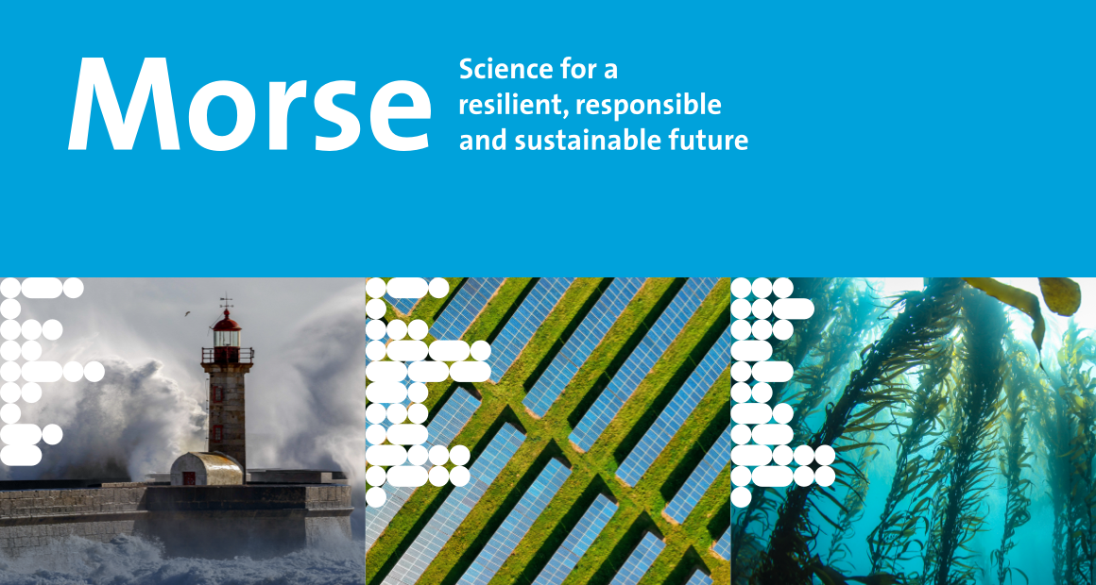
Call for Papers
Maastricht Observatory for Responsible, Resilient and Sustainable Societies, Economies and Enterprises
3rd Annual Conference 2023
Track: Resilience to Climate Change
Maastricht, the Netherlands, 23-25 October 2023

Track Chairs:
Dirk Broeders, Tina Comes, Mark Sanders, Paul Smeets, and Serdar Türkeli

Description of the track

Climate Change has become unavoidable (IPCC, 2023). The question is not if, but how much climate change we must prepare for. This will impact our economy, society, and way of life in many ways. In this track we will focus on the financial sector and invite empirical and theoretical research papers and work in progress that investigate how physical climate risks may affect income flows and balance sheets and give guidance on how economic agents should prepare for these risks. Adaptation to climate change can take the form of “technological fixes” (e.g. higher dikes, flood protection, water storage etc. etc.) but may also involve changing regulation and reforming institutions to build a more resilient economic system. Examples of topics that would be relevant in this track include the risks that physical climate change poses for residential and commercial real estate and corporate fixed assets, indirect impacts on income, employment and production through disruptions in regional, national and global supply chains and the network effects of damages to energy or transport infrastructures.

Key topics and research questions of the track

- How can the physical risks of Climate Change affect private households’ income and financial position?
- How can the physical risks of Climate Change affect firms’ income and financial position?
- How do the impacts of Climate Change travel through networks, such as (global) value chains, input-output relationships and creditor-debtor relationships?
- How can circuit-breakers and more resilient economic structures be designed and developed?
- What can be the role of local, regional, national and European government and public agencies in making our economy resilient to climate change?

References:
Ghadge, A., Wurtmann, H., & Seuring, S. (2020). Managing climate change risks in global supply chains: a review and research agenda. International Journal of Production Research, 58(1), 44-64.
Kim, D., & Lim, U. (2016). Urban resilience in climate change adaptation: A conceptual framework. Sustainability, 8(4), 405.
Bowen, A., Cochrane, S., & Fankhauser, S. (2012). Climate change, adaptation and economic growth. Climatic change, 113, 95-106.

The deadline for submissions is 1 June, 2023.
All submissions must use the submission template and use the submission procedure on the webpage otherwise they will not be considered for review.
Submit your paper here.

The registration for the MORSE 2023 will be open until 31st August, 2023.
Register here.

