***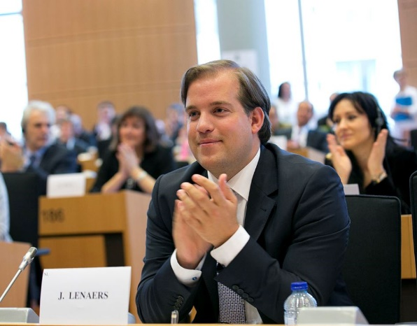*Jeroen Lenaers (Dutch)**

Alumnus Master European StudiesMember of the European ParliamentBrussels, BelgiumYear of graduation: 2008

Being the most international university in The Netherlands, Maastricht University is the perfect starting point for pursuing a career without borders. It was only when I started working in the European Parliament that I fully realised how much I benefited from my years of studying European Studies in Maastricht. During the Masters programme you study the European Union in a diverse, exciting and multidimensional way. You learn how to quickly switch between different policy fields, be open-minded and flexible. But equally important, you learn how to cooperate in an international and truly multicultural environment. It is such skills and experiences that are invaluable for any person with international ambitions.

\*\*\*\*\*\*\*\*\*\*\*\*\*\*\*\*\*\*\*\*\*\*\*\*\*\*\*\*\*\*