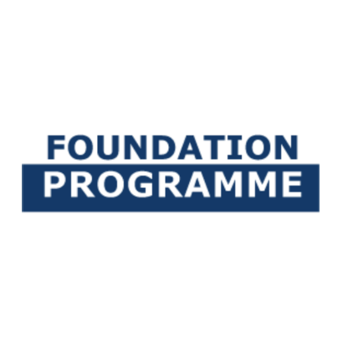 | 

Curriculum Vitae
The CV is a summary of your personal details, educational history, interests and work experience (if applicable).
Please send in your completed C.V. and make sure to provide us with all educational results you have.

Personal details
First name: |  |  |  |  |  | Last name:
Date of birth:
E-mail address:

Nationality: |  | Country of residence:

Country of birth: |  | Official language of the region(s) you grew up in:

Language you speak at home: |  | FP-Bachelor track applied for:

Secondary education
Name secondary school: |  | Country:

Name diploma: |  | (Expected) Graduation date:

Language of instruction and examinations in your secondary education:

Education after secondary education (if applicable)
Name school: |  | Name study programme:

Start date: |  | End date:
Did you graduate? | YES | NO

Address:

Other activities (if applicable)
Extracurricular activities/Community involvement/Work experience (if applicable):

Any other information you would like to share with the Board of Admissions:

