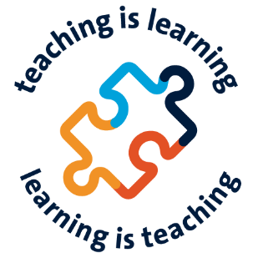
UM Education Days 2026
Tell us about your idea for a session
Please note that the workshop sessions this year will have a length of 75 minutes.

- Title
An informative and catchy title will make people curious to attend your session. Compelling titles not only tell participants what the session will be about, they also capture why they should choose yours! Need inspiration? Check last year’s abstracts. You can change the title of your session until 01-03-2026.
The title of your session:

- Presenter(s)
Tell us who you are and about your formal role and connection with teaching and learning.
A note on co-creation. For sessions for the UM Education days, we encourage co-creation of sessions: between staff from various faculties and central units, and between staff and students. If you are staff, students are the ultimate beneficiaries of your ideas and practices. We encourage you to explore how they can provide essential insights in the form of feedback and reflection and ideas for design.
We also encourage students to take the lead on developing sessions – and here as well, we encourage co-creation, connecting the perspectives and creativity of students and staff.

Name | UM email address | Formal role | Connection with teaching and learning

- Keywords
Which three to five words capture the essence of what your session is about? Try to be specific – which words should grab the attention of the participants at the UM Education Days, and pique their interest in your session?
Your keywords:

- Engaging your participants
Sharing expertise and enthusiasm can be done in all kinds of ways. A story well told can be as inspiring as an engaging activity. That said, it fits the culture of the UM Education Days if participants can play an active role in sessions. How will you engage your participants, what they do, discuss, experiment, experience or explore your topic?
How you will engage your participants:

- Take-aways
What will participants in your session take with them as they go back to work and studies? This can be a very concrete practice, or a new perspective on aspects of teaching and learning, inspiration to develop a novel approach. Think of your take-aways as a ‘call for action’: what do you hope participants will do because of your session?
The (main) take-aways of your session:

- Session teaser
Based on what you filled in for the items above, write a 'session teaser’ of no more than 200 words. We will use the abstract to present your session in the programme overview for the UM Education Days. Like the title, you can still change this abstract until 01-03-2026. After that date, the programme for the UM Education Days will go ‘live,’ and people can start registering for sessions.
We suggest you address the following items in your teaser:
1. What is the topic of the session?
2. Why is this topic relevant, why does it matter?
2. What will happen during the session?
3. What will participants gain from attending the session?

Your session teaser:

