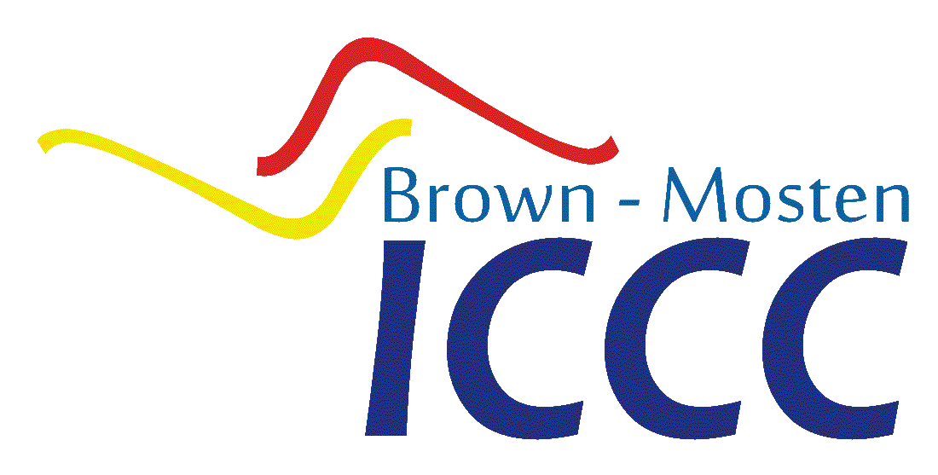
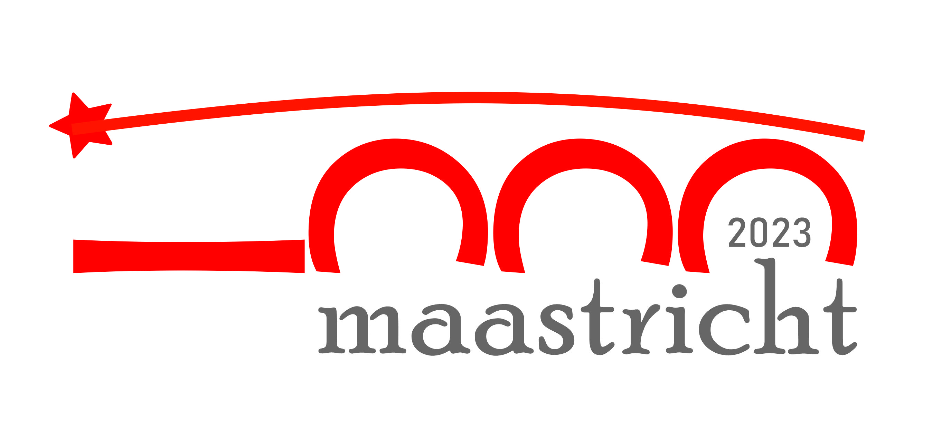
REGISTRATION FORM ICCC 2023
APRIL 12-15, 2023
FACULTY OF LAW, MAASTRICHT
UNIVERSITY
MAASTRICHT, THE NETHERLANDS

REGISTRATION FORM ICCC 2023, APRIL 12-15, 2023
Gender | [ ] Mr [ ] Mrs [ ] Ms [ ] Miss
First name
Last name
Titles in front
(e.g. Prof. Dr.)
Titles behind
(e.g. LLM, SS)
E-mail address(es)
Phone number(s)
I am a … | [ ] Team member  [ ] Coach  [ ] National Representative  [ ] Other (please specify):
Name and address of university
For team members only: study and (graduation) year
Name of the country
Special needs (e.g. dietary needs)
Accomodation in Maastricht
Date of Arrival
Date of Departure
Is planning to attend | [ ] Informal dinner on Wednesday evening  [ ] Students' dinner on Thursday evening  (for students only)  [ ] Cultural exchange evening/pancake cruise  on Friday evening  [ ] Awards dinner on Saturday evening  [ ] Social program (which can be only scheduled once the team letters have been drawn)
 | Place an X between the brackets if the text applies.

