


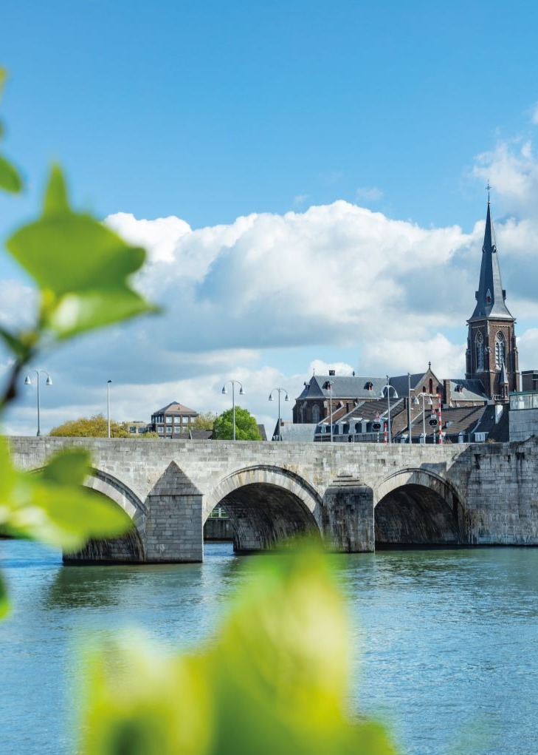

WHO
Collaborating Centres
Hybrid Conference to Launch two
www.maastrichtuniversity.nl
Conference 10:00-17:00hrs | Plenary session 10:30-12:30hrs
MECC Forum | Maastricht
Public Health Leadership and Workforce Development
Regions for Health and Cross-Border Public Health
October 10, 2025

Program
October 10, 2025

WHO Collaborating Centre Regions for Health and Cross-Border Public Health
and
WHO Collaborating Centre for Public Health Leadership and Workforce Development welcome you warmly!

10.00-10.30 Registration
10.30-12.30 Joint morning Symposium | Rooms 0.4 – 0.5
10.30 Welcome address by WHO CC directors
Prof. dr. Katarzyna Czabanowska, International Health, Maastricht University
Director of WHO CC for Public Health Leadership and Workforce Development

Prof. dr. Christian Hoebe, Social Medicine, Maastricht University
Director of WHO CC Regions for Health and Cross-Border Public Health
10.45 Part 1: Endorsement speeches | Chair: Prof. dr. Christian Hoebe
Dr. Hans Kluge, Regional Director, WHO Europe (online)
Prof. dr. Stef Kremers, Vice-dean of FHML, Maastricht University
Dr. Jarno Habicht, WHO Representative, Head of the WHO Country Office in Ukraine (online)
Dr. Bettina Menne, WHO Senior Advisor for Healthy Settings and Coordinator of the WHO Regions for Health Network
Dr. Natasha Azzopardi-Muscat, Director of the Division of Health Systems at the World Health Organization Regional Office for Europe (online)
Prof. dr. Silvia Evers, Scientific director of the research institute CAPHRI, Maastricht University
11.45 Part 2: Discussion panel
What opportunities does the WHO CCs bring to your organization/region?
Chair: Prof. dr. Katarzyna Czabanowska
Moderator for online Q&A: Dr. Olga Gershuni
Dr. Zsofia Pusztai, WHO Representative for Czech Republic
Dr. Brigitte van der Zanden, Former Director euPrevent
Dr. Bettina Menne, WHO Senior Policy Advisor for Healthy Settings and the Coordinator of the WHO Regions for Health Network
Prof. dr. Mary Codd, President-Elect of ASPHER
Dr. Nataliia Piven, Unit Lead (Public Health and IHR/Preparedness), WHO Country Office in
Ukraine (online)
Mrs. Veerle van Zelst-de Vries, MHA, Director ‘Prevention and Vitality’ Program UM-MUMC+
Questions from the audience

12.30-13.30 Lunch, Praetorium

Parallel sessions
October 10, 2025

13.30-16.00 SESSION 2: WHO Collaborating Centre
Regions for Health and Cross-Border Public
Health | Room 0.5
Prof. dr. Christian Hoebe
13:30 Presentations
Moderator: Dr. Brigitte van der Zanden
Former Director euPrevent

‘WHO CC from an infectious disease control
perspective’
Prof. dr. Christian Hoebe
Chair Department of Social Medicine, Maastricht
University
Program Leader Living Lab Public Health Mosa

‘Cross-border public health in the Meuse-Rhine
Euroregion’
Dr. Brigitte van der Zanden
Former Director euPrevent

“Labor migration case; COVID-19 and cross-
border workers’
Dr. Alena Kamenshchikova
Assistant Professor
Department of Health, Ethics and Society
Department of Social Medicine
Department of Medical Microbiology, Infectious
Diseases and Infection Prevention
Maastricht University

‘Adolescent substance uses in cross-border
Regions’
Dr. Rianne Reijs
Researcher Department of Social Medicine,
Maastricht University
Medical specialist Youth Health Care, Public
Health Services South Limburg

14:30 Break (20 min)

14:50 Citizen Summit Simulation
Chairs: Dr. Rianne Reijs & Dr. Alena Kamenshchikova

‘Co-designing future research agenda for
Cross-Border Public Health’

Participants will take on different roles in this
simulation of a citizen summit.

A Citizen Summit is a large event that gathers public involvement and feedback on issues affecting people's lives and circumstances.

By simulating such a summit, participants will learn
different perspectives regarding health in a regional
setting, prevention and public health.

16:00 Networking

13.30-16.00 SESSION 1: WHO Collaborating Centre for Public Health Leadership and Workforce Development | Room 0.4
Prof. dr. Katarzyna Czabanowska &
Robert Otok, Managing Director ASPHER
13.30 Introduction
Address | Dr. Tomas Zapata
Regional Advisor, Health workforce and service delivery,
WHO regional office for Europe (online) &
Dr. Emilia Aragón de León
WHO CC focal point and Technical Officer, Public Health
Policy and strategy development, WHO Regional Office
for Europe
Workplan | Dr. Matt Commers
Associate Professor Dept. of International Health
13:45 Achievements
Chair: Prof. dr. Katarzyna Czabanowska & Robert Otok

‘Environmental Health Competency Framework’
Dr. Sinaia Netanyahu, WHO Regional Office for Europe,
European Centre for Environment and Health
Andreas Mertens, Researcher and HPIM Master student

‘WHO Public Health Leadership Courses’
Thanos Myloneros, Public Health Officer, WHO Office on
Quality of Care and Patient Safety (online)

‘Professionalization of the PHW and Capacity
Building (Leadership in One Health and
Emergency Preparedness)’
Olga Aleksandrova, Public Health Services Officer,
WHO Country Office in Ukraine

‘Professionalization of the PHW in Czech Republic
focus on Public Health academic education’
Eliška Selinger, Charles University, Prague

14:30 Break (15 min)

14:45 Interactive session
Dr. Mark Bakker, Assistant Professor INTHEALTH
Martina Parić, Lecturer INTHEALTH
Issam Alsamara, Researcher INTHEALTH

15:15 Current work
Chair: Prof. dr. Milena Pavlova
Dept. of Health Services Research, Maastricht University
Vice-director of WHO CC for Public Health Leadership
and Workforce Development

‘Enumeration of the PHW’
Dr. Timo Clemens, Associate Professor INTHEALTH

‘Digital competencies for the PHW’
Dr. Rok Hrzic, Assistant Professor INTHEALTH

‘Intersection of public health and healthcare
Professional practice’
Prof. dr. Lorena Dini, Head of Working Group Health Policy and Systems Research and Innovation, HPSRI, Charité, Universitätsmedizin Berlin

‘Economic evaluation competencies for PHW’
Prof. dr. Milena Pavlova, Health Services Research,
Maastricht University
Vice director of WHO CC for Public Health Leadership
and Workforce Development

16:00 Networking

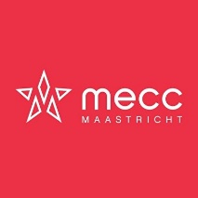
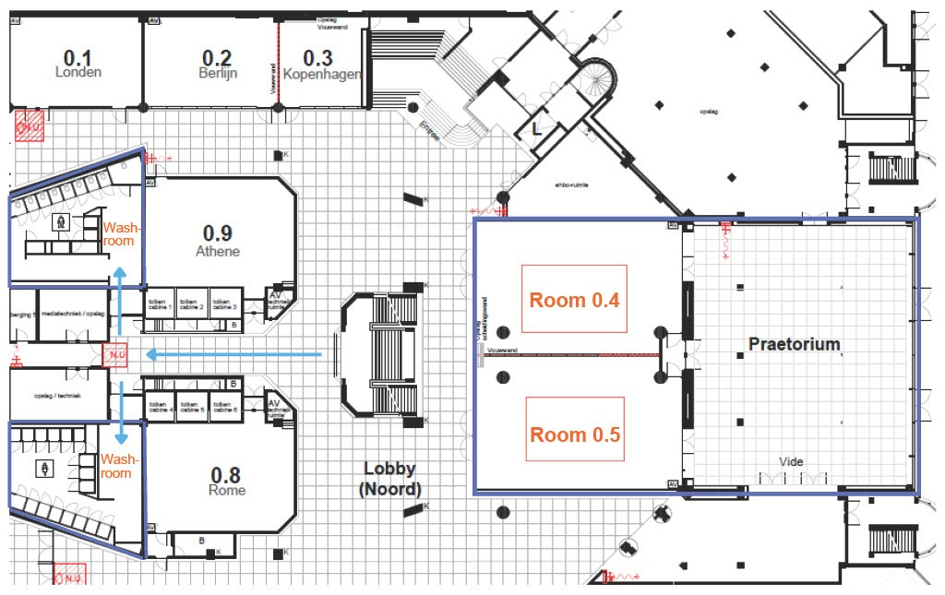
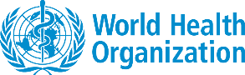
In collaboration with:
Disclaimer: When participating in events or occasions where photography or video recordings are made, it is assumed that implicit consent is given for the use of the images. Participation in or visit to the website, without written notification of objection, constitutes consent to the recording and distribution of your image.

WHO Collaborating Centre Regions for Health
and Cross-Border Public Health
Maastricht University Maastricht University
Department of International Health Department of Social Medicine
WHO Collaborating Centre WHO Collaborating Centre
for Public Health Leadership and Regions for Health and Cross-Border
Workforce Development Public Health
www.maastrichtuniversity.nl www.maastrichtuniversity.nl
WHO Collaborating Centre
for Public Health Leadership and Workforce Development

