Name candidate
e-mail address

Committee of Deans

your reference our reference direct line Maastricht
2023 +31 (0)43 388 30 96

Subject: name candidate

Concerning the dissertation: title,
the Committee of Deans has received:

a) the judgement of the Judging Committee with respect to the manuscript;
b) the judgement of the supervisor with respect to the defensibility of the propositions

The Rector has approved the draft title page of the dissertation which mentions the title
of the dissertation and the place, day and hour of the degree ceremony:

Aula, day, date, year and time

The doctoral candidate may print the dissertation. We need 6 physical copies.
It is required to send a digital copy of the doctoral thesis to the UM Library, see www.umlib.nl/submit-doctoral-thesis.

The Committee of Deans,
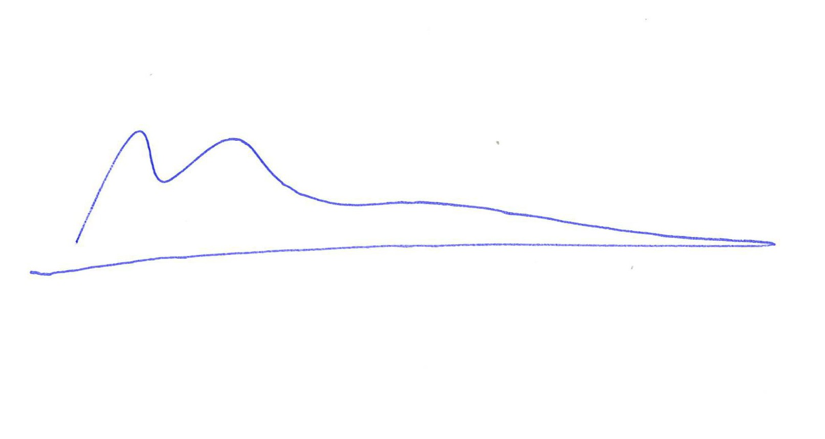
Prof. Dr. Jan Smits
Rector Magnificus

Supervisors:
Co-supervisors:
Dean of the Faculty of

