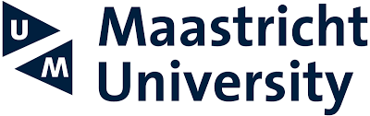


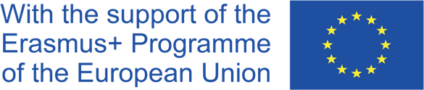

JEAN MONNET INTERNATIONAL SYMPOSIUM

Towards Global Governance of Investment Law: Perspectives from Asia and the EU

4–5th April 2022

Bringing together high-level experts on international investment, EU, and Thai law, the EU funded Erasmus+ Jean Monnet International Symposium organized in Bangkok by Thammasat law faculty and Metro embraced timely and relevant topics, ranging from investment protection and dispute settlement, to sustainable development, and the international rule of law. The Symposium sought to foster a policy dialogue between the academic and policy community in the EU and Thailand with a view to promoting multilateralism in international investment and trade.

The first day of the Symposium investigated the past experiences of Investor–State Dispute Settlement (ISDS) and the possibility of a global reform of this system. In recent years, the legitimacy of ISDS has come under fire due to high profile cases of investors’ challenges against States’ regulatory actions. Within EU Member States, citizens and NGOs have led calls for greater transparency and public engagement on ISDS, which led to an investment protection standards and dispute settlement reform within the EU. The new mechanism for resolving investment disputes is known as the Investment Court System (ICS) and it has been included in the EU’s free trade and investment protection agreements with Canada, Singapore, Vietnam, and Mexico. The EU has also been improving substantive standards in its investment agreements in order to safeguard the right of States to regulate. The EU vision of the new model of investment dispute settlement in the form of a Multilateral Investment Court (MIC) has been proposed in the framework of a global reform of ISDS taking place in UNCITRAL. The perspectives from Thailand and Asia on establishing a rules-based multilateral investment system for the success of the global reform of international investment law were discussed.

The second day of the Symposium explored the extraterritorial application of the European Green Deal (EGD) and its potential impact on Thai investors. The EGD, adopted by the European Commission in December 2019, set out the blueprint for transformational change of the EU and its engagement with the World. The Commission has envisaged the development of policies for clean energy supply across the economy, industry, production and consumption, large-scale infrastructure, transport, food and agriculture, construction, taxation and social benefits. Furthermore, the Commission is working on 12 legislative proposals (Fit for 55) that are likely to impact trade and investment with third countries. In particular, the recently proposed draft legislation on Corporate Sustainability Due Diligence requires implementing comprehensive mitigation processes for adverse human rights and environmental impacts in major companies value chains could have a major impact on trade between the EU and Thailand.

About organising universities

Thammasat University is located at the centre of Bangkok, Thailand. It was inaugurated in 1934 and has offered legal education ever since. The origin of the Thammasat University, Faculty of Law (TU Law) can be traced back to the Law School of the Ministry of Justice established in 1897. TU Law is the oldest continuously operating law school in the country and plays a significant role in shaping Thai ideologies, politics, legal education and the judicial system. The curricula have continually influenced the development of legal education in Thailand,

Maastricht University is located at the heart of Europe regularly ranks as one of Europe's leading universities. The University has been placed in the top 300 universities in the world. Its Institute for Transnational Legal Research (METRO) contributes by executing high-quality international legal research.

