Honours Programme

Projects 2023-2024

Maastricht University
Faculty of Arts and Social Sciences (FASoS)

Coordinator Excellence Programs FASoS:
Prof. G. Verbeeck
georgi.verbeeck@maastrichtuniversity.nl

International Election Observation and Survey Methodology

Prof. dr. Hans Schmeets

This project/seminar will be closely related to Hans Schmeets’ on-going research in the field of international election assessments and survey methodology. He will share his research in the position of a statistical/election analyst in the ‘core team’ of the OSCE/ODIHR Election Observation Missions (EOMs) in recent years, including various EOMs in the Ukraine and Belarus covered by over 1,000 international election observers. On this topic he has authored International election observation and assessment of elections (CBS: The Hague 2011).Various aspects of the research within EOMs will be outlined: the sample of the polling stations, the bias introduced by the selection of the polling stations, the design of the observer report forms, data-collection of observers’ findings by the use of ‘magic pens’, and how to analyze the quantitative data and written comments. Furthermore, the impact of the background (e.g. nationality) on the assessment of the elections will be illustrated based on over 30 elections. The seminar will also be linked to the methodology used in (large scale) social surveys conducted by Statistics Netherlands (e.g.: social cohesion, wellbeing, labor force, religion, elections). The students will, if feasible due to Covid-19, visit Statistics Netherlands (in Heerlen). The various phases of survey research will be demonstrated, including the activities within the questionnaire laboratory and live-interviews at the ‘Computer Assisted Telephone Interview’ department.

This seminar aims at providing: (1) basic knowledge of survey-research methodology in general; (2) backgrounds of the assessments of elections by international organizations, the OSCE in particular; (3) knowledge of the methodology used in social surveys and election assessments; (4) practical sessions on data-collection and data-processing; (5) practical sessions of analyzing (quantitative and qualitative) data based on EOMs conducted in recent elections in various OSCE member states (e.g. Ukraine, Kazakhstan, Azerbaijan, Russia, Georgia).

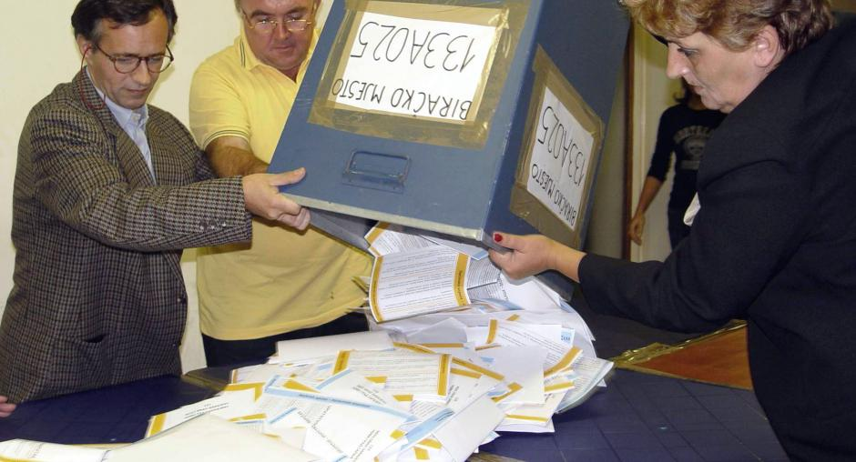

Contact : h.schmeets@maastrichtuniversity.nl
After the Empire:
Writing, rewriting and representing the history of colonialism

Prof. dr. Georgi Verbeeck

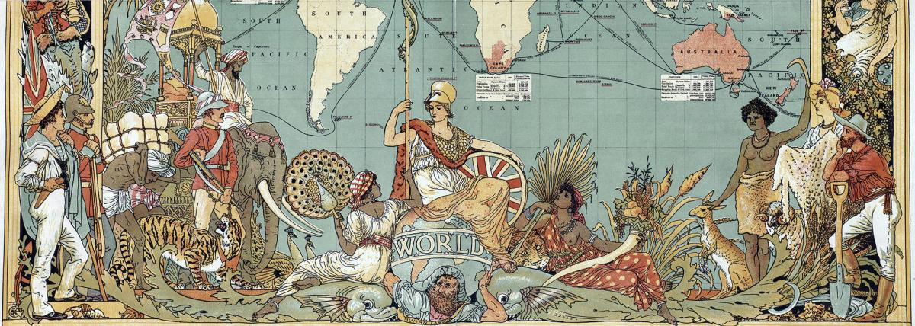

Since many years the age of colonialism has been closed in Europe and in the Western world. However, its memory and legacies remain subject to recurrent controversies. Historians in various countries are rewriting the history of colonialism, while public discussions on museums, statues and monuments related to the colonial age continue to rage globally.

This seminar invites students with a vivid in public history. Not only will new views and interpretations in academic historical research be studied, but the public domain of history as well. Students are encouraged to focus on a specific case, such as: scholarly controversies among historians on colonialism, contemporary history textbooks on colonialism, the representation of colonialism in old textbooks, current controversies on the establishment of (new) museums and exhibitions, activism and the writing of history, the global movement to demand apologies and/or reparations for slavery.

Suggested topics for further research are: the ‘Mapping Slavery’- project in various Dutch cities; controversies surrounding the AfricaMuseum in Tervuren (Belgium); museums and exhibitions on colonialism in Berlin; the reparation for slavery movement; restitution of colonial art and heritage; public apologies, and may others. Further suggestions are welcome.

Contact : georgi.verbeeck@maastrichtuniversity.nl
Making ‘Sense’ of Cultural Ecosystems:
Researching the cultural fields using sensory research methods

Professor Dr. Emilie Sitzia

What does the cultural field look like in Maastricht? How are museums, galleries, libraries, universities, art schools, centers and labs connected to each other and to existing communities? What constitutes the network of cultural resources in Maastricht? And how to research this cultural ecosystem? These are the core questions that Emilie Sitzia and American scholar Carissa DiCindio want to work on with you.

Studying cultural ecology allows us to interrogate systems within cultural institutions and examine their relationships to their communities. It allows researchers to critically examines institutional hierarchies and colonial practices of traditional institutions and re-envisions these spaces as participatory and multivocal and as sites for engagement and critical dialogue by breaking down the barriers between the institution and the public.
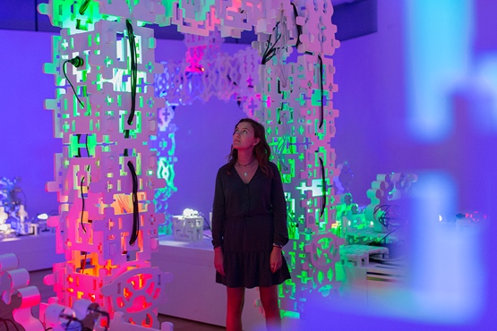

But how to research such complex ecosystems? Sensory research methods are essential to many fields of practice. They involve attuning and developing sensory skills but also an ability to collect and analyse sensory data. Within the ‘Senses-based learning’ research project we aim to give these essential sensory knowledge and skills space and visibility in university education. We want to change your education. We want to develop 'senses-based learning', that is learning units specifically training (and evaluating) sensory skills in existing physical, digital or hybrid teaching programmes across faculties and we want students to be involved throughout this development.

This is where you come in! In this seminar you will discover sensory research methods and train them to analyse cultural ecosystem. How do you map sound in a cultural institution? How to document visitor’s movement? How to analyse an exhibition space? How to use walking as a research method? How to use a sensory diary? What is sensory ethnography?

During this project we will teach you a range of sensory methodologies to study the cultural ecosystem of Maastricht. We will alternate between experiments and self-directed research session to map and reflect on an aspect of that cultural ecosystem of your choice.

This seminar will be led by Emilie Sitzia and Carissa DiCindio. Emilie is an expert on word/image relationship, on the impact of art on audiences and participatory practices, she has recently obtained a Comenius leadership fellowship to develop ‘Senses-based learning’ with and for the students. American researcher Carissa DiCindio’s expertise is in Art and Visual Culture Education and she works on engagement, on the civic aspect of museums, on museum ecologies, and on walking as a research method.

Contact : emilie.sitzia@maastrichtuniversity.nl
Digital Challenges in Cultural Heritage

Prof. dr. Nico Randeraad

Museums, archives, libraries and other cultural heritage organizations are undergoing a profound transformation. Not only have virtually all traditional card catalogues been replaced by electronic management systems, but also content itself is digitized at a dizzy speed. The amount of born digital material (from social media to art) is dramatically growing. Printed books have become virtual e-books, paintings are turned into pixels, objects are integrated in 3D representations. More and more people will see digitized copies of archival documents, newspapers, prints, statues, rather than study and ‘feel’ the original material. Digitization has given an enormous boost to research based on digital methods and has given digital humanities a fixed place in academic curricula. Whereas the advantages are obvious and more often than not overexposed, the challenges are daunting. Questions of provenance, originality, technological innovation, digital literacy, transience, ownership, expertise, et cetera abound.

This Honours Course takes stock of these developments and offers opportunities to study the digital turn in cultural heritage from different perspectives. The course is open to philosophical approaches, experimentation with new digital methods, research into pedagogic and educational implications, and exploration of all other practical and academic consequences of the digital turn. The Honours students who participated in 2021 wrote a report supporting the initiative to establish a Digital Studies Lab at FASoS, which has become the PLANT. In 2023 the students produced a participatory digital tour in Maastricht, seducing visitors to immerse themselves in some of the city’s lost spaces.
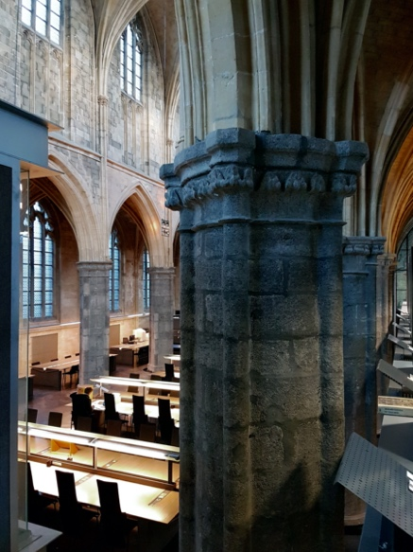
Nico Randeraad holds a chair in regional history and is also director of the Centre for the Social History of Limburg (SHCL), a research and documentation centre affiliated with FASoS. SHCL has large archival, library and imagery collections, and is trying to deal with all kinds of digital challenges in its daily practice. Students are warmly invited to help us thinking about solutions and new paths. Meetings will take place, when possible, in the beautiful venue of the Historical Centre for Limburg, Sint Pieterstraat 7, not far from the UM inner-city library.

Contact : n.randeraad@maastrichtuniversity.nl
Social Justice and Digital Scholarship

Professor Dr. Susan Schreibman
in collaboration with Anna Villarica, Teaching Fellow

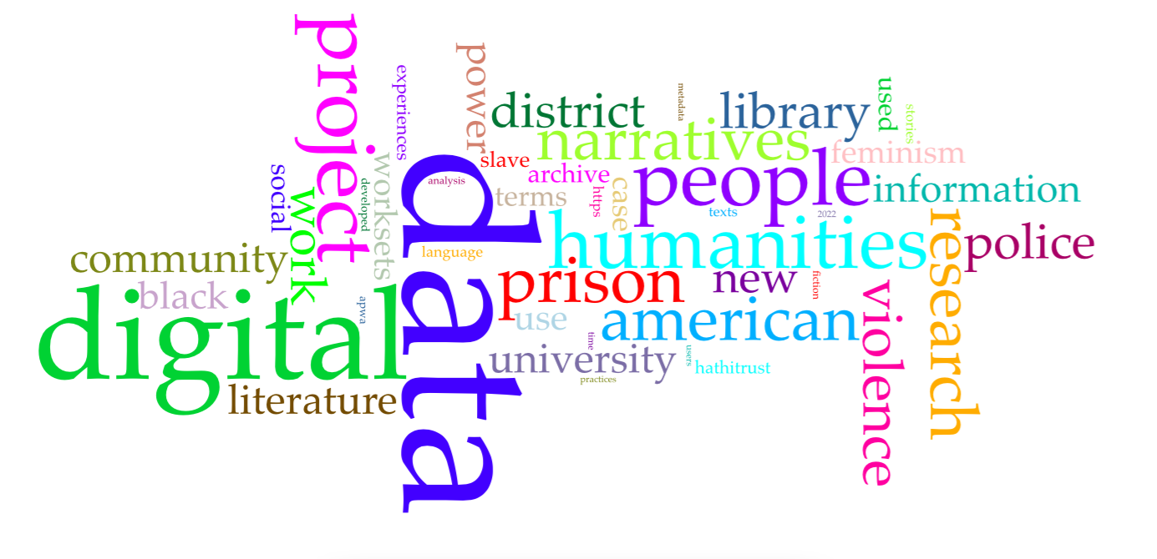

Do you want to be part of a new initiative that is exploring what is involved in taking a social justice approach to digital scholarship? Where can information be found documenting best practice when working with indigenous or minoritized communities? What are the best tools, theories, and approaches for conducting ethical scholarship? Where can instructors get best practice examples of how to embed social justice concerns into their teaching practice? A course we are developing for #dariahTeach, an open-source, online teaching and learning platform for the digital arts and humanities, is addressing these questions.

Social Justice in the Digital Humanities (DH), is exploring, both theoretically and practically, how digital scholarship (from universities, archives, libraries, and heritage institutions) are intervening in issues of social justice in their work, research and teaching. The course is taking a case-based approach in which we both invite developers of relevant projects, frameworks, software or university courses to author a case study, or we author case studies based on publicly-available material with the developers input (and blessing).

This honours course will provide students with an exciting opportunity of collaborating with the course developers to bring their interests and talents to the project by sourcing and developing new case studies. Students will also develop and augment the online learning environment on the #dariahTeach platform. They will enrich the case studies with multimodal, interactive content that engages users. The instructors will teach students the necessary technical skills. Students can also practise their online social media skills by managing our social media accounts (e.g. Twitter and LinkedIn).

Current case studies include

- how crowdsourced data and mapping tools draw attention to femicide in Mexico
- how archival research combine with GIS to fight black erasure in South Africa
- how metadata makes queer literature more accessible for researchers and the public
- how digital platforms make visible the life and testimonies of incarcerated individuals in the United States and to help to reassess legal practices

Contact : s.schreibman@maastrichtuniversity.nl
Learning with Gardens

Dr. Anna Harris
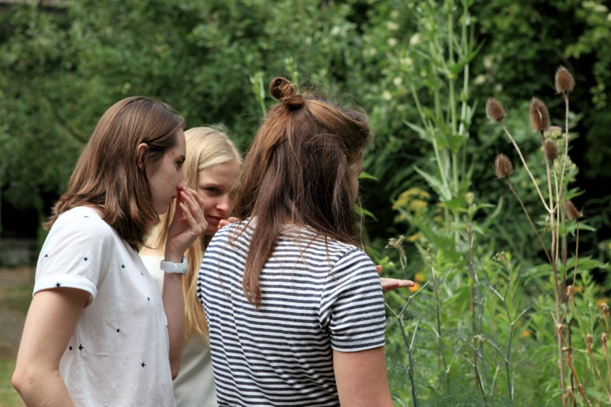

Gardens have been part of European universities for more than 500 years. Scholars from various disciplines have documented the importance of botanical gardens for example, in scientific and medical research and learning, and as manifestations of the colonial enterprise. Yet a more practical interest in these gardens as educational spaces has dwindled and today university botanic gardens are more likely to be tourist sites than classrooms. COVID-19 has accelerated the need to rethink learning spaces, yet to date the work done on outdoor education focuses on children.

In this 2023/2024 Honours project you will revisit the garden as a space to learn, while getting your hands dirty. This project builds on the work done by previous Honours students who, in the last two years have conducted ethnography, written policy recommendations, made videos and designed a festival for the FASoS garden. These projects looked at “Learning in Gardens”, and “Learning about Gardens”. In this third and final project in the series, “Learning with Gardens”, students will have the opportunity to work on one or more of three suggested interventions which think with gardens:

- Composting: in collaboration with Bandito’s Espresso and Jan van Eyck Academy Materials Lab, this intervention will take a practical, artistic and academic look at composting, working with Donna Haraway’s theoretical ideas on composting while making composts.
- Urban gardening: in collaboration with the CNME (local city gardening initiative) and UCM, this intervention will involve reading a text together and working in the FASoS garden.
- Anti-colonial gardens: in collaboration with Marres and the Sense-Based Learning project, this intervention will involve reading several essays by writer Jamaica Kincaid and working with seeds, rethinking colonial and mastery narratives of/in the garden in the process.

These interventions may result in bigger workshops or similar, depending on student’s ideas. In previous years all meetings have been conducted in local gardens, and students have had a lot of autonomy in shaping a creative, engaging project to align with their interests, with clear guidance from the supervisor. We will continue this tradition, and also make something new together!

Contact : a.harris@maastrichtuniversity.nl

Sustainability:
Turning structural challenges into possibilities?

Professor Dr. Stijn Neuteleers

There is mounting evidence and awareness of two environmental crises, namely climate change and global biodiversity loss. At the same time, there is, however, also a long list of (structural) challenges to the transition towards sustainability. These include, among others, collective-action problems (on interpersonal, international, intergenerational and intrapersonal levels); different valuations of nature; and wide diverging wealth and power positions (cf. environmental justice). Gardiner speaks of a ‘perfect moral storm’: a perfect combination of different storms that inhibit us from moral action, especially with regard to problems such as climate change. While this could easily be seen as a reason for fatalism, understanding these structural complexities should rather be seen as precondition for action: what is their content, how do they relate to each other, and to which extent are they actually relevant explanations for inaction?

In this course, we will first examine together some of the basic ideas in the literature on the three challenges mentioned above, namely (i) multi-level collective-action problems, (ii) plural valuations, and (iii) environmental (in)justice (readings will include parts of: Gardiner 2011; Neuteleers 2012; O’Neill, Holland & Light 2008; Hourdequin 2015; Walker 2012). Second, based on our discussions, we then can focus on particular relations, aspects and/or contexts, to see how these challenges can provide insights towards opportunities: which conditions do we need to create to tackle particular sustainability challenges?

Students will write one-author (ca 4000 words) or two-author (ca 6000 words) end-papers about one aspect of this broad problem field. The topic allows for different disciplinary perspectives, from all three FASoS Bachelors.

In 2023-2024, within the context of the chair of ‘philosophy of sustainable development’, some activities will be organized, including a workshop with environmental philosophy scholars from the Low Countries. The workshop presentations can also serve as input to the discussion in this course. Students are also welcome to contribute to this workshop (discussion, organization, presentation), allowing them to develop other academic skills.

Contact : stijn.neuteleers@maastrichtuniversity.nl

Exploring Ethics in the Wild

Professor Dr. Tsjalling Swierstra

The word ‘ethics’ not only refers to a branch of philosophy that studies right and wrong, good and bad. It also refers to the value systems that people, usually unwittingly and routinely, apply when deciding how to live, act, and value. This second type of ethics is studied by sociologists, ethnographers, and historians, but also by social psychologists and (evolutionary) biologists. This descriptive work on ethics is interesting for the normative work done by philosophers, for instance because it can make them aware of their biases.

In this honours course we will start by reading two influential empirical books on ethics, one by an ethnographer, the other by a moral psychologist. Their messages overlap, nuance, and complement each other.

Joseph Henrich argues in The WEIRDest People in the World: How the West Became Psychologically Peculiar and Particularly Prosperous (Harvard, 2020) that inhabitants of WEIRD (Western, Educated, Industrialized, Rich and Democratic) countries have an ethical outlook that stresses individualism and impartial justice, which contrasts with other populations who focus more on relations and group allegiances. The historical origin of this difference, according to Henrich, is to be found in how in the Middle Ages the Catholic Church reorganized inheritance laws!

Jonathan Haidt argues in The righteous mind: Why good people are divided by politics and religion (Pantheon Books, 2012) that people’s ethical beliefs are mostly caused by emotions and intuitions, rather than by reasoning. According to him people share the same limited set of moral foundations (Care, Fairness, Authority, Sanctity, Loyalty, and Freedom), but liberals typically stress Care and Fairness, while conservatives focus on Authority, Sanctity, and Loyalty. Both offer contrasting interpretations of Freedom.

Having finished the books, we will collect and discuss critical reviews of both books, and try to come up with our own position. In the final stage students will write, individually or in pairs, a short essay applying the theoretical framework(s) to a contemporary problem like the debates on migration, climate change, or the Ukraine war.

Contact : t.swierstra@maastrichtuniversity.nl

