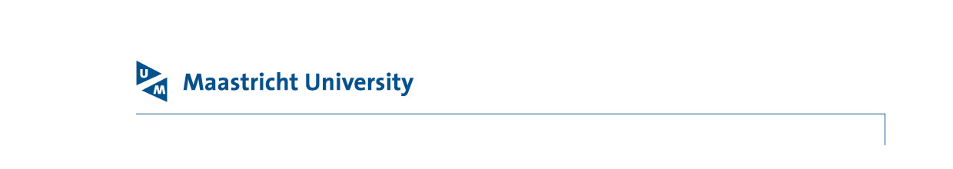

People & Development - PO Box 616 | NL 6200 MD Maastricht

Guest agreement information form
For guest agreements. Not for internships and external registrations.

Please fill out sections A, B and C

Please send this form together with the mentioned documents to the People Support Office
Copy of valid passport
Copy of current residence (both sides) or work permit (if applicable)

- Personal details
Last name (as in passport)
Initials and first name
Name by which you are known |  |  |  |  | Gender |  | M F
Date of birth
Place and country of birth
BSN (Dutch Citizen Service Number)
Permanent address
(Street name/House number/ Postal code/City/Country)
Nationality
If you are not a national of the country you currently live in, do you have a valid residence permit for this country? | yes, attach a copy of this permit (both sides) no
Do you hold a valid residence permit for the Netherlands? | yes, attach a copy of this permit (both sides) no
Permanent address during UM employment (incl. postal code/city/country)

Residence address during UM employment (incl. postal code/city/country)
Private email address
Phone number |  |  |  | In case of emergency
Marital status | married single permanently cohabiting
Preferred attribution | your name partner name partner name and your name
Complete below if your non-Dutch partner and/or children will join you to the Netherlands

Will your partner join  you in the Netherlands? | yes, per date: no not applicable
Will your child(ren) join you in the Netherlands? | yes, per date: no not applicable
Name of partner
Initials and first name of partner

Date and place of birth of partner
Details of child(ren) joining you in the Netherlands | Last name
Details of child(ren) joining you in the Netherlands | Initials and first name
Details of child(ren) joining you in the Netherlands | Date of birth
Details of child(ren) joining you in the Netherlands | Nationality
Details of child(ren) joining you in the Netherlands | Relationship to you
Details of child(ren) joining you in the Netherlands | Current foreign address

B. Place of Employment
In what country will you fulfil your work duties for UM? | in the Netherlands only | in the Netherlands and in another country. | in another country.  I will not work for UM in the Netherlands, only abroad.

C. Completed truthfully
Date on which you completed this form / /

Signature: …………………………………………………

¹ For more information please contact our International Staff Support Office (isso@maastrichtuniversity.nl). 2 Should your permanent address change after the start of your employment, you have to change the address in SuccessFactors yourself.
Please do not list a company email address.
To qualify for the same rights as married couples, the partnership must be registered or attested to by a notary.
The preferred attribution will also determine the display name of your UM account.

